
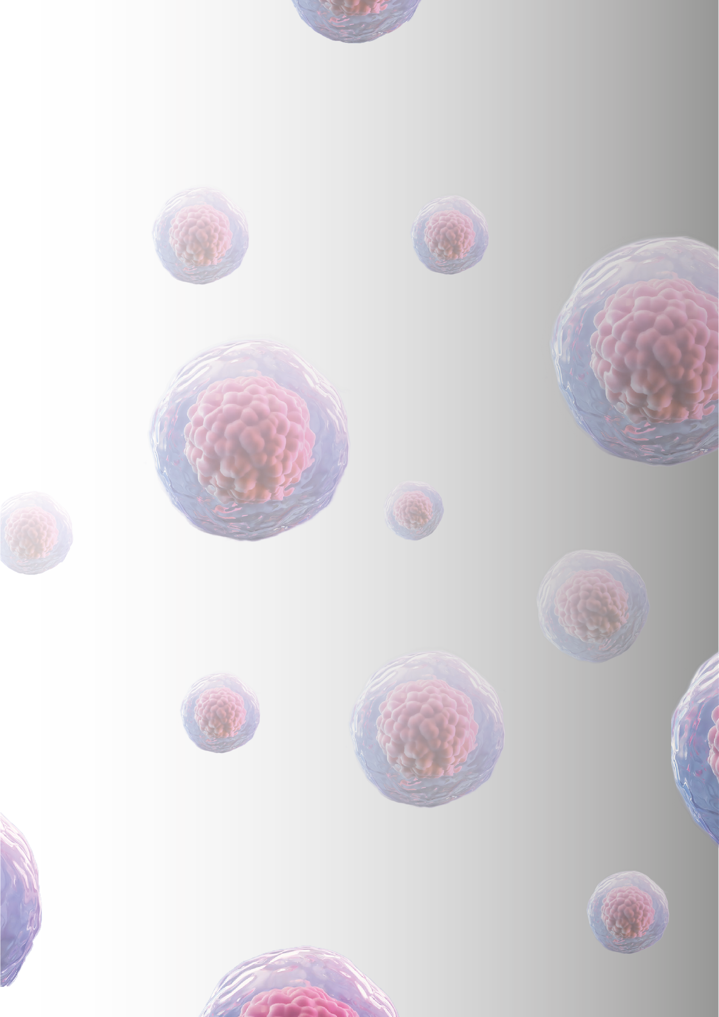
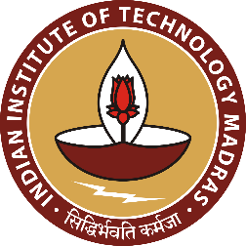
International Conference on Cancer Biology:
Hyundai Centre for Cancer Genomics
National Cancer Tissue Biobank, Department of Biotechnology,
Indian Institute of Technology Madras, Chennai-600036
Email: iccb26.iitm@gmail.com / Ph: 044-22575108 / nctb.iitm.ac.in

To CHENNAI
Dr. Keith T. Flaherty, MD, FAACR Director of Clinical Research, MAY 20th 2026
Professor of Medicine, Harvard Medical School
Boston, Massachusetts, USA

Dear Dr. Keith T. Flaherty,
Greetings from IIT Madras, Chennai!
It has been long time, how are you? hope everything is going well for you.

I have the great pleasure of inviting you as a faculty to the forthcoming “International Conference on Cancer Biology: Molecular Mechanisms, Genomics and Novel Therapeutics” taking place in Chennai from February 4th to 6th, 2027.

This conference is hosted by the Hyundai Centre for Cancer Genomics, IoE-CoE on Cancer Genomics and Molecular Therapeutics and Office of Global Engagement, Indian Institute of Technology Madras, Chennai will bring together scientists, clinicians, and representatives from the pharmaceutical industry to discuss innovation in novel target identification and drug development, preclinical models, genomics and the impact of new discoveries in cancer biology. Understanding the pathways and mechanisms which cause cancer and regulate the biological behaviour of tumour cells has led to the development of numerous new agents and innovative targets for clinical trials. This conference will bring together delegates from all over the world, igniting a huge exchange of information, promoting and developing global partnerships in translational cancer research. We look forward to the leaders in this field to set the agenda towards this goal. In view of your outstanding contribution in this field, we are proud to invite you to deliver a key note lecture in this meeting.

Madras, which recently reverted to its historical name Chennai, is the capital of the South Indian State of Tamil Nadu. It is the fourth largest metropolis of India, after New Delhi, Bombay and Calcutta. Chennai is a seaside (and a major port) city where the sea is a rhapsodist blue, hugging the second largest beach in the world. It has many monuments and temples exemplifying the contributions of the Chola and Pallava Dynasties to the ancient Dravidian civilization. Chennai also has the ancient churches and Cathedrals pointing to British heritage of 160 years.

The weather is pleasant in February with temperature hovering in the range of 22-to-25-degree celcius and humidity in the order 40-60%.

IIT-Madras, Chennai is one of the premier institutes of research and teaching in India. Established in 1958 it recently celebrated the golden jubilee and has been in the frontline of training graduates who fill a significant space all over the world in the field of Science and Technology. The biotechnology division of this reputed institute is 20 years old and has already contributed many milestones in this field. The ever so growing specialties in this department is matched none less by the cancer biology division.

We are looking forward to your presence that would provide an opportunity for stimulating interactions with the participants.
Looking forward to hearing from you. With regards

Dr. S. Mahalingam

Chief Patrons
Prof. V. Kamakoti
Mr. Tarun Garg
Patron
Preethi Aghalayam
Prof. Ashwin Mahalingam
Mr. Gopala Krishnan
Dr. R. Venkatraman
Organizing Secretaries
Prof. S. Mahalingam
Dr. Sridhar Sivasubbu
Dr. S.G. Ramanan
Organizing Committee
Dr. Puneet Anad
Dr. Vinod Scaria
Prof. Suresh K. Rayala
Dr. Nathiya Muthalagu
Dr. Shantanu Pradhan
Dr. Anushka Gupta
Dr. J. Janarthinakani

February 4th to 6th, 2027
Indian Institute of Technology Madras, Chennai-600036, India.

T.T.J. Auditorium, ICSR,
Molecular Mechanisms, Genomics and Novel Therapeutics

